**Create JDBC Connection**

1. Download JDBC driver 5.1.41 (latest ver) from <https://dev.mysql.com/downloads/connector/j/5.1.html>  
   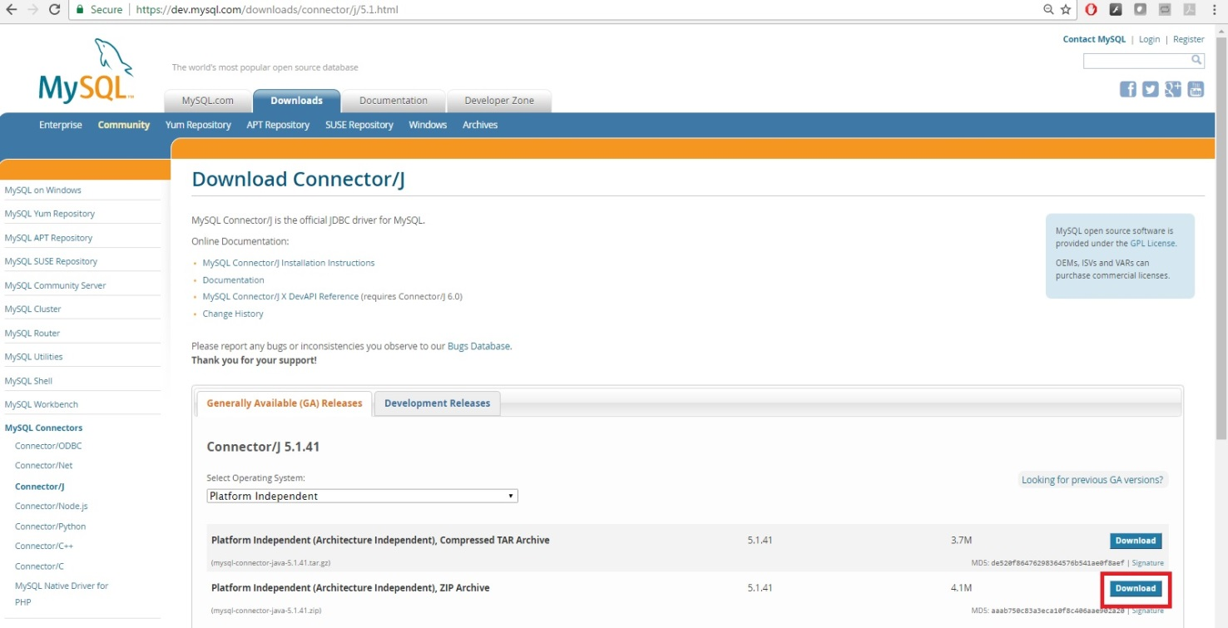

I downloaded the zip file.

1. Unzip the zip file
2. Add the jar file to the Java project as shown below in either Eclipse or NetBeans.

**Eclipse**

1. Unzip the downloaded JDBC driver.
2. Add the JDBC driver jar file to project folder
   1. Right click JRE System Library -> Import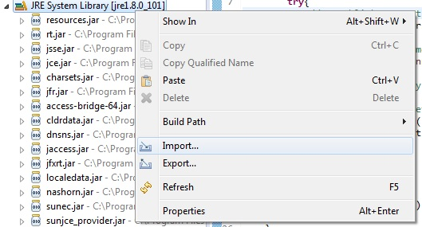
   2. Choose File System
   3. Locate the directory the JDBC jar file has been unzipped

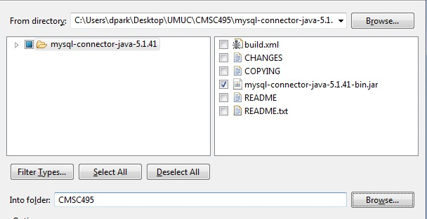

3) The jar file must now be added to the project build path

1. Right click project folder -> Properties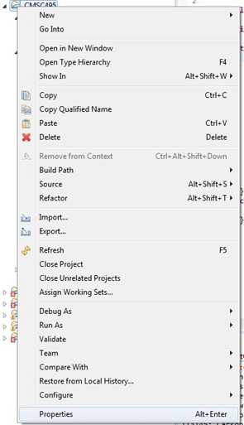
2. Go to Java Build Path -> Add JARS and find the JDBC jar file that has been imported to the project folder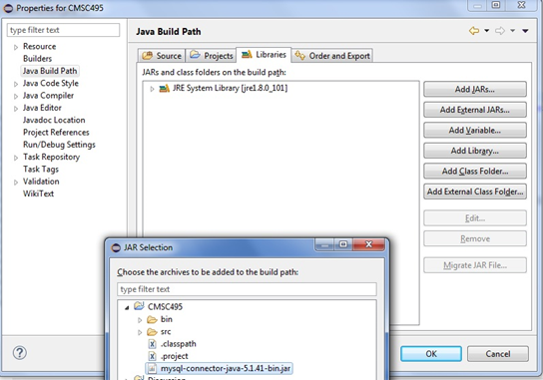

**NetBeans**

1. Unzip the downloaded JDBC driver.
2. Add the JDBC driver jar file to project folder
3. Right click Libraries -> Add/Jar Folder

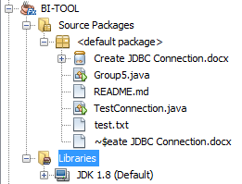

1. Locate the unzipped JDBC jar driver

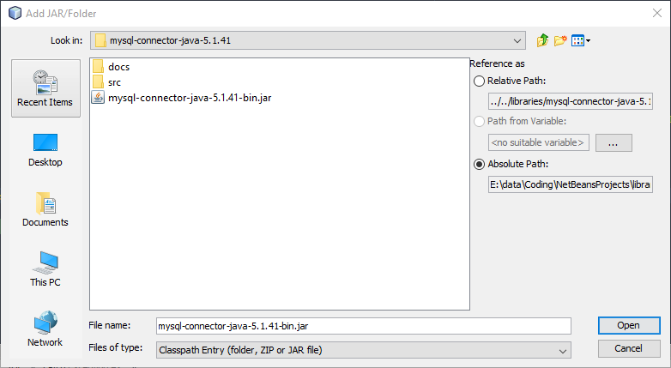

1. Select Open